**‘I am the way and the truth and the life.’**

**Reading:** John 14:1-6

Jesus said, “Do not let your hearts be troubled. You believe in God. Believe in me also. There are many rooms in my Father’s house. If this were not true, would I have told you that I am going there? Would I have told you that I would prepare a place for you there? If I go and do that, I will come back. And I will take you to be with me. Then you will also be where I am. You know the way to the place where I am going.”

Thomas said, “Lord, we don’t know where you are going. So how can we know the way?”

Jesus answered, “I am the way and the truth and the life. No-one comes to the Father except through me.

**Thought about the reading**

Imagine you have gone to visit a friend in a different town, and you don’t know how to find their house. Your friend might tell you how to get there from the bus stop. They might tell you to go down the road, turn right at the roundabout then left at the traffic lights, then left again…. It might be difficult to remember!

But imagine how much better it would be if your friend said, ‘I will meet you at the bus stop and, show you the way’ and then walked with you to their house.

Jesus says that he has a place ready for us in heaven with his father. But he does not just tell us how to get there. He says that he is the way – he goes with us to show us the way. He is the truth, so we can believe what he says. He is the life, and he will give us life forever with him and his father in heaven.

**Prayer**

Thank you Jesus, that you have a place for us in Heaven. Thank you that you are the way to heaven. You go with us to show us the way. Thank you that we can trust what you say, and you will give us life.

Help me to listen to you and to walk with you in your way.

Amen

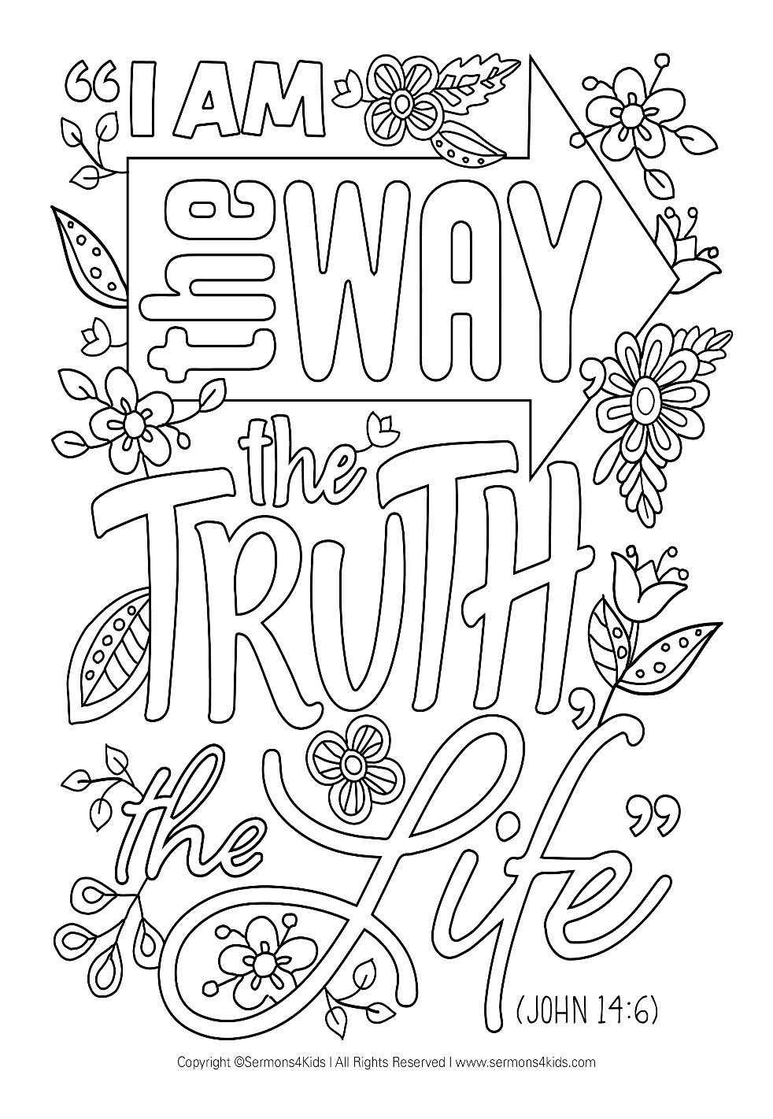

**Cambridge Causeway**

Autumn 2023

Bible Study notes

**Jesus said ‘I am…’**

**5. I am the way and the truth and the life**

By Chrissy Cole